Chapter 1 Notes: Introduction to Living Things
Lesson 1: What is Life?
What Are The Characteristics of All Living Things?
ORGANISM: a living thing
- All living things have a cellular organization, contain similar chemicals, use energy, respond to their surroundings, grow and develop, and reproduce.
  - Cellular Organization: all organisms are made of CELLS: the basic unit of structure and function in an organism.
  - May have one or many cells.
    - Single-celled = UNICELLULAR
    - Many cells = MULTICELLULAR
  - The Chemicals of Life: Water (most abundant), Carbohydrates (energy source), Proteins and Lipids (building blocks), and Nucleic Acids (genetic materials)
  - Energy Use: organisms get energy from taking in and breaking down materials
  - METABOLISM: the combination of chemical reactions through which an organism builds up or breaks down materials.
    - Use energy to grow, repair injuries, reproduce and all processes of life!
  - Response to Surroundings: All organisms react to changes in their environment
  - STIMULUS: a change in an organism’s surroundings that causes the organism to react.
  - RESPONSE: an organism’s reaction to a stimulus
  - Growth and Development: all living things grow and develop
  - DEVELOPMENT: the process of change that occurs during an organism’s life, producing a more complex organism.
    - Organisms use energy to make new cells.
  - Reproduction: all organisms produce offspring that are similar to the parents.
  - Different types of reproduction:
    - ASEXUAL REPRODUCTION: involves only one parent and produces offspring that are identical to the parent.
    - SEXUAL REPRODUCTION: involves two parents and combines their genetic material to produce a new organism that differs from both parents.

Where Do Living Things Come From?
- Living things arise from other living things through reproduction.
People believed that life could appear from nonliving things 400 years ago.
- Example: Flies produced by rotting meat.
SPONTANEOUS GENERATION: the idea that living things can arise from nonliving sources.

Redi’s Experiment
1600s -- Italian Doctor -- Francisco Redi -- Designed experiment to disprove spontaneous generation
CONTROLLED EXPERIMENT: scientist carries out a series of tests that are identical in every respect except for one factor.
- Manipulated variable: the one factor that a scientist changes in an experiment
- Responding Variable: the factor that changes as a result of changes to the manipulated variable
Steps in Redi’s Experiment:
- Placed meat in two identical jars. He covered one jar and left one jar uncovered.
- After a few days, maggots (young flies) were on the meat in the open jar. There were no maggots in the covered jar.
- Concluded that flies laid eggs on the meat in the open jar. The decaying meat did not produce maggots.
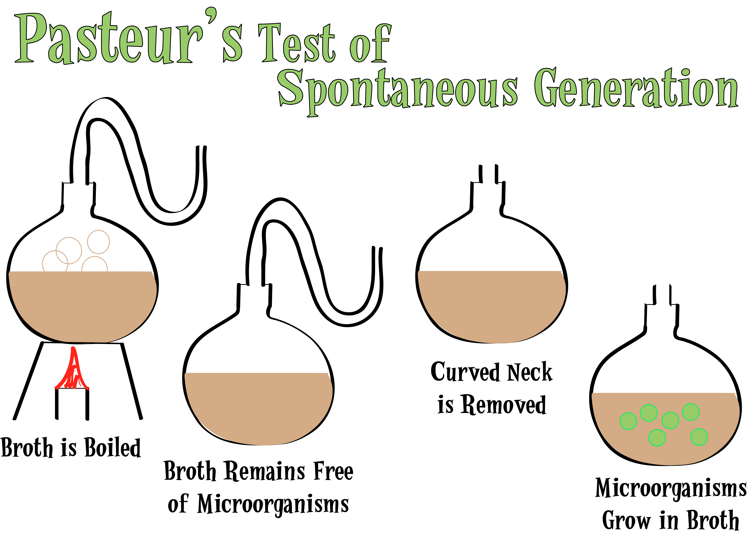
Pasteur’s Experiment
Louis Pasteur (1800s) designed another experiment to test spontaneous generation.
Steps in Pasteur’s Experiment
- Put clear broth into flasks with curved necks. The neck lets air in but keep bacteria out. He boiled the broth to kill all of the bacteria already present in it.
- A year later -- The broth is clear of bacteria. Pasteur breaks the neck off of one flask.
- A few days later -- The broth without a broken neck is clear of bacteria. The flask with the broken neck has bacterial growth.

What Do Living Things Need to Survive?
- All living things must satisfy their basic needs for food, water, living space, and stable internal conditions (homeostasis)
Food: organisms need a source of energy to live (food!)
There are different ways to obtain energy
  - AUTOTROPH: organisms that make their own food.
  - HETEROTROPHS: organisms that cannot make their own energy.
    - Must eat another organism to survive
Water: all living things need water to survive (most organisms can only go a couple of days w/o water)
- Needed for getting chemicals from surroundings, breaking down food, growing, moving substances in their bodies, and reproduction.
Living Space: all organisms need a place to live -- place to get food and water and find shelter
- Limited amount of space on Earth so some organisms must compete for space to live.
Stable Internal Conditions: organisms must be able to keep their internal body conditions the same, even when conditions around them change.
HOMEOSTASIS: maintaining stable internal body conditions.

Lesson 2: Classifying Life
Why Do Biologists Classify Organisms?
More than 1 million kinds of organisms on Earth!
Scientists place all living organisms into groups to organize them.
CLASSIFICATION: the process of grouping things based on their similarities.
- Biologists use classification to organize living things into groups so that the organisms are easier to study.
TAXONOMY: the scientific study of how organisms are classified

The Naming System of Linneaeus
Taxonomy includes naming of organisms.
1730s Swedish scientists Carolus Linnaeus created a system of naming organisms that we still use today.
- Organisms are put into groups based on physical features and given a two-part scientific name.
- BINOMIAL NOMENCLATURE: Classification system in which each organism is given a unique, two-part scientific name.

Genus and Species
GENUS: (1st word in organism’s scientific name) a classification grouping that contains similar, closely related organisms.
- Example: Genus Felis includes pumas, house cats, and marbled cats -- all share similar characteristics
SPECIES: (2nd word in organism’s scientific name) a group of similar organisms that can mate with each other and produce offspring that can also mate and reproduce

Using Binomial Nomenclature
- Name is written in italics
- Only 1st letter of word is capitalized
- Uses Latin words
- Example: Homo sapiens

What Are the Levels of Classification
The Major Levels of Classification
The levels go from broad to narrow
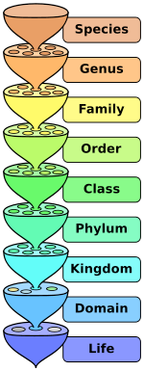
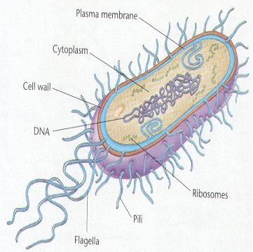
- A domain is the broadest level of organization.
-Domain --> Kingdom --> Phylum --> Class --> Order --> Family --> Genus --> Species

How Are Taxonomic Keys Useful?
- Taxonomic keys are useful tools that help determine the identity of organisms.
- Consists of a series of paired statements that describes the various physical characteristics of different organisms.

Lesson 3: Domains and Kingdoms
How Are Organisms Classified Into Domains and Kingdoms?
Today, we use a three-domain system to classify organisms.
- Organisms are placed into domains and kingdoms based on their cell type, their ability to make food, and the number of cells in their bodies.

Domain Bacteria
Some are autotrophs and some are heterotrophs
Bacteria are PROKARYOTES: unicellular organisms whose cells lack a nucleus.
NUCLEUS: a dense area in a cell that contains nucleic acids -- the chemical instructions that direct the cell’s activities.
- Nucleic acids are not contained in a nucleus in prokaryotes.

Domain Archaea
Archaea -- Greek meaning “ancient”
Unicellular prokaryotes.
Some are autotrophs and some are heterotrophs
Differ from bacteria in chemical makeup

Domain Eukarya
EUKARYOTES: organisms with cells that contain nuclei. Broken down into four kingdoms
- Protists: any eukaryotic organism that cannot be classified as a fungus, plant or animal.
  - “odds and ends” kingdom (some autotrophs, some heterotrophs) (most unicellular, some multicellular)
- Fungi: mushrooms, molds and mildew.
  - Most are multicellular, but some are unicellular
  - Found almost everywhere on land, but only a few in fresh water.
  - All are heterotrophs -- most feed on dead/decaying organisms
- Plants: multicellular eukaryotes that mostly live on land.
  - All are autotrophs
  - Provide food for most heterotrophs on land

- Animals: multicellular eukaryotes that are all heterotrophs.
  - Have different adaptations that allow them to locate food, capture it, eat it and digest it.
  - Live in very diverse environments around Earth.

Lesson 4: Evolution and Classification
How Are Evolution and Classification Related?
Charles Darwin (1859): British scientist that published an explanation for how species of animals could change over time.
EVOLUTION: the process of change over time.
Darwin thought that evolution occurs by means of natural selection (the process by which individuals that are better adapted to their environment are more likely to survive and reproduce than other members of the same species)
  - Certain organisms are more similar because they share a common ancestor
- Species with similar evolutionary histories are classified more closely together.

Branching Tree Diagrams
BRANCHING TREE DIAGRAM: shows probable evolutionary relationships among organisms and the order in which specific characteristics may have evolved.
- Begin at base with the common ancestor of all the organisms in the diagram.
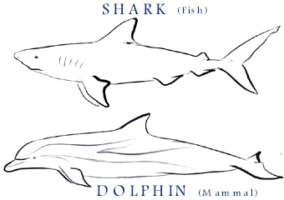
- Grouped according to SHARED DERIVED CHARACTERISTIC: a trait, like fur, that the common ancestor of a group had, and passed on to its descendants.
Determining Evolutionary Relationship
Scientists compare structures of organisms to one another, along with chemical makeup of the organisms’ cells.
Unrelated organisms can evolve the similar characteristics due to the environment they live in.
CONVERGENT EVOLUTION: the process by which unrelated organisms evolve characteristics that are similar.

